SUMMARY PAPERS:

Attentive Convolutional Neural Network based Speech Emotion Recognition: A Study on the Impact of Input Features, Signal Length, and Acted Speech

- CNN with multi-view learning(emotions labels+valence/arousal labels) objective function.
- Compare system performance using different lengths of the input signal
- different types of acoustic features and
- different types of emotion speech (improvised/scripted)

CORPUS: IEMOCAP (improvised + scripted)
ACNN = CNN + attention mechanism (clasification tasks)

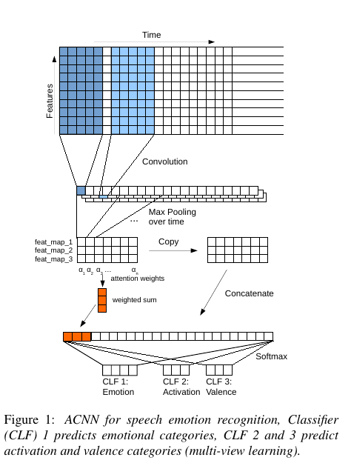
MODEL

Input→ audio signals splitted into S overlappings segments, we extract the features of them and we create a matrix W ∈ R^{d×s} , → 2D kernels Convolution → máx pooling(remove noise) → attention vectors → join maped features from Convolutional layer with attention results(fully connected layer input) → softmax layer → prediction(classification task)

ATTENTION MECHANISM:

***¿****************QUÉ ES?
(http://www.wildml.com/2016/01/attention-and-memory-in-deep-learning-and-nlp/) → Attention and Memory in Deep Learning and NLP

With an attention mechanism we no longer try encode the full source sentence into a fixed-length vector. Rather, we allow the decoder to “attend” to different parts of the source sentence at each step of the output generation. Importantly, we let the model learn what to attend to based on the input sentence and what it has produced so far. So, in languages that are pretty well aligned (like English and German) the decoder would probably choose to attend to things sequentially. Attending to the first word when producing the first English word, and so on.
The important part is that each decoder output word now depends on a weighted combination of all the input states, not just the last state. The ‘s are weights that define in how much of each input state should be considered for each output. So, if is a large number, this would mean that the decoder pays a lot of attention to the second state in the source sentence while producing the third word of the target sentence. The are typically normalized to sum to 1 (so they are a distribution over the input states).
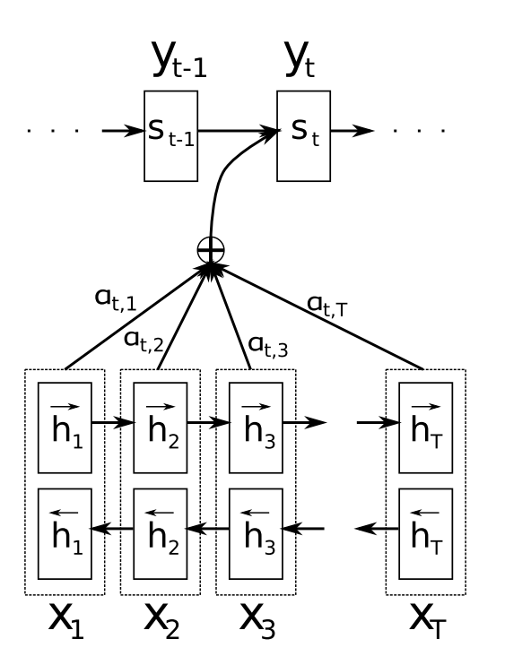

COST OF ATTENTION
We need to calculate an attention value for each combination of input and output word. If you have a 50-word input sequence and generate a 50-word output sequence that would be 2500 attention values. That’s not too bad, but if you do character-level computations and deal with sequences consisting of hundreds of tokens the above attention mechanisms can become prohibitively expensive.

Instead OF PAYING ATTENTION YOU HAVE TO TRY ALL THE COMBINATION→ HAVING MEMORY MORE THAN ATTENTION

An alternative approach to attention is to use Reinforcement Learning to predict an approximate location to focus to. That sounds a lot more like human attention, and that’s what’s done in Recurrent Models of Visual Attention.

The basic problem that the attention mechanism solves is that it allows the network to refer back to the input sequence, instead of forcing it to encode all information into one fixed-length vector.

**************************

INPUT FEATURES

We use the following feature sets: (a) 26 logMel filter-banks,
(b) 13 MFCCs, (c) a prosody feature set, and (d) the extended
Geneva minimalistic acoustic parameter set (22 features - eGeMAPS). For
all feature sets we apply mean and standard deviation normalization for each speaker independently.

EXPERIMENTS:
- Try ACNN with different features: improvised, best performance with logMel MV(althoug with single vew approach it doesn’t change a lot) 61,95 → 62,11 . MFCC and eGEMPAPS also give good results
- Signal length: it seems that it’s not really important to get long signals, so with 3-4 seconds is enought, even with less seconds it could work

The analysis suggests that improvised speech is in general more variable and therefore makes it easier to discriminate affective states. Investiga-
tion with more data would be helpful to confirm these findings.

FRAMEWORK: Theano

ADIEU FEATURES? END-TO-END SPEECH EMOTION RECOGNITION USING
A DEEP CONVOLUTIONAL RECURRENT NETWORK

Model: CNN(remove noise)1-d convoltuion + LSTM
Recent trend: Deriving a representation of the input signal directly from raw data→ nw learns an intermediate representation with all the data and selects the ones that are better instead of passing some selected features.

Input. We segment the raw waveform to 6 s long sequences after we preprocess the time-sequences to have zero mean and unit variance to account for variations in different levels of loudness between the speakers. At 16 kHz sampling rate, this corresponds to a 96000-dimensional input vector.

Temporal convolution: F=40 space time finite impulse filters with 5ms window.
Pooling across time

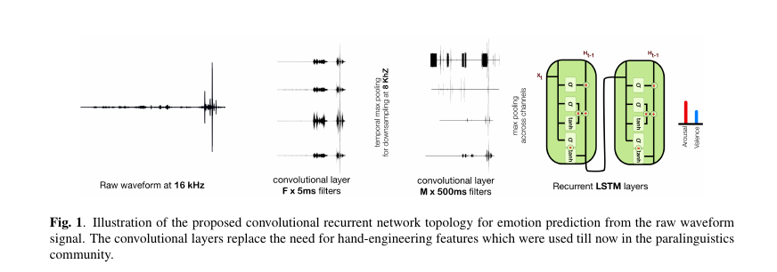
….
EXPERIMENTS:
- SVMs with a linear-polinomial and RBF kernels — libsvm library
- BLSTM-DRNNs (3 hidden layers, 64 units each, sigma=0.1)
- Sobre estos aplican eGeMAPS y ComParE features
y compararan con los resultados obtenidos con el modelo propuesto que utiliza raw data.
Post-processing step: median filtering, centring, scaling and time-shifting aplicadas sobre als predicciones del dev DS.

Evaluating deep learning architectures for
Speech Emotion Recognition

Fig. 1 is a sketch of the proposed SER system which follows
a frame-based processing formulation that utilizes Fourier-
transform based filter bank speech spectrograms and a deep multi-
layered Fig. 1 is a sketch of the proposed SER system which followsneural network to predict emotion class probabilities for
a frame-based processing formulation that utilizes Fourier-
transform based filter bank speech spectrograms and a deep multi-
layered neural network to predict emotion class probabilities for
each frame in the input utterance.
N×TLet X ∈ be a speech utterance or speech stream sliced into
each frame in the input utterance.
N×TLet X ∈ be a speech utterance or speech stream sliced into

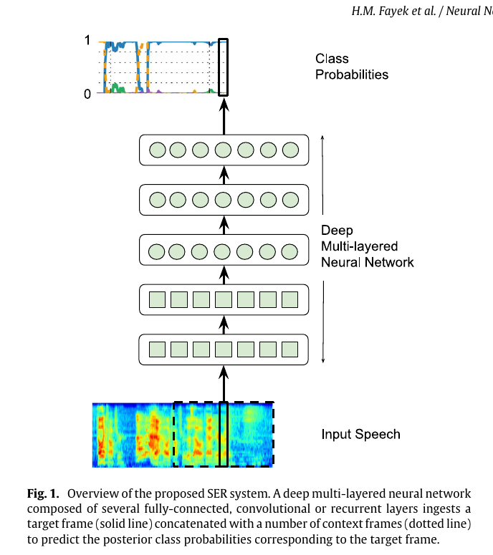

Audio was analyzed using a 25 ms Hamming window withstride of 10 ms. Log Fourier-transform based filter banks with 40
coefficients distributed on a Mel scale were extracted from each
frame. The mean and variance were normalized per coefficient for
each fold using the mean and variance computed using the training
subset only. No speaker dependent operations were performed.
Since the data was labeled at an utterance-level, all frames in an
utterance inherited the utterance label.

Speech Emotion Recognition with Deep Learning
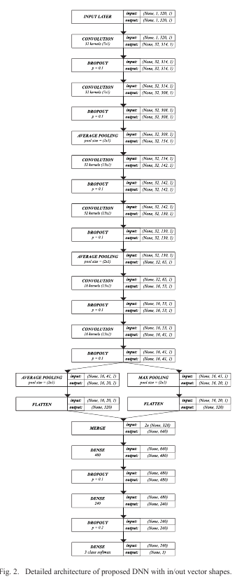

Emotion Recognition On Speech
Signals Using Machine Learning

The prime objective of this paper is to
recognize emotions in speech and classify them in 7
emotion output classes namely, anger, boredom, disgust,
anxiety, happiness, sadness and neutral. The proposed
approach is based upon the Mel Frequency Cepstral
coefficients (MFCC) and energy of the speech signals as
feature inputs and uses Berlin database of emotional
speech.

different classification algorithms namely, Support Vector
Machine (SVM) , Random Decision Forest and Gradient
Boosting. Random forest was found to have the highest

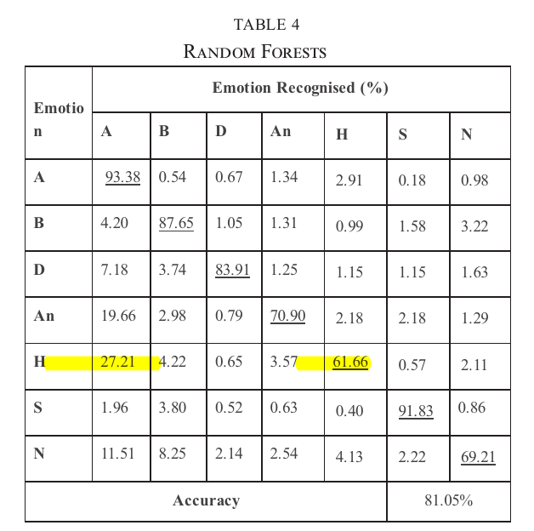

End-to-End Multimodal Emotion Recognition
using Deep Neural Networks

* Muchos ejemplos de estado del arte que podríamos mirar.

Speech nw:
Input. We segment the raw waveform to 6 s long sequences
after we preprocess the time-sequences to have zero mean and
unit variance to account for variations in different levels of
loudness between the speakers. At 16 kHz sampling rate

Temporal Convolution. We use F = 40 space time finite
impulse filters with a 5 ms window (size of 80) in order to
extract finer-scale spectral information from the high sampling
rate signal (16 kHz).

Pooling across time. The impulse response of each filter is
passed through a half-wave rectifier (analogous to the cochlear
transduction step in the human ear) and then downsampled to
8 kHz by pooling each impulse response with a pool size = 2.

Temporal Convolution. We use M = 40 space time finite
impulse filters of 500 ms window (size of 4000). These are
used to extract more long-term characteristics of the speech
and the roughness (i.e., irregularities) of the speech signal.

Max pooling across channels. We perform max-pooling
across the channel domain with a pool size of 10. This reduces
the dimensionality of the signal while preserving the necessary
statistics of the convolved signal.

Dropout. probability of 0.5.

Objective function:

Multimodal Network. After training the visual and speech
networks, the LSTM layers are discarded, and only the ex-
tracted features are considered. The speech network extracts
1280-dimensional features while the visual network extracts
2048-dimensional features. These are concatenated to form a
3328-dimensional feature vector and fed to a 2-layer LSTM
with 256 cells each. The weights of the LSTM layers are
initialized following Glorot based initialization [43], and the
visual and speech networks are initialized utilizing the weights
of the unimodal models. Finally, the whole network is trained
end-to-end.
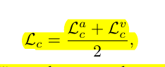
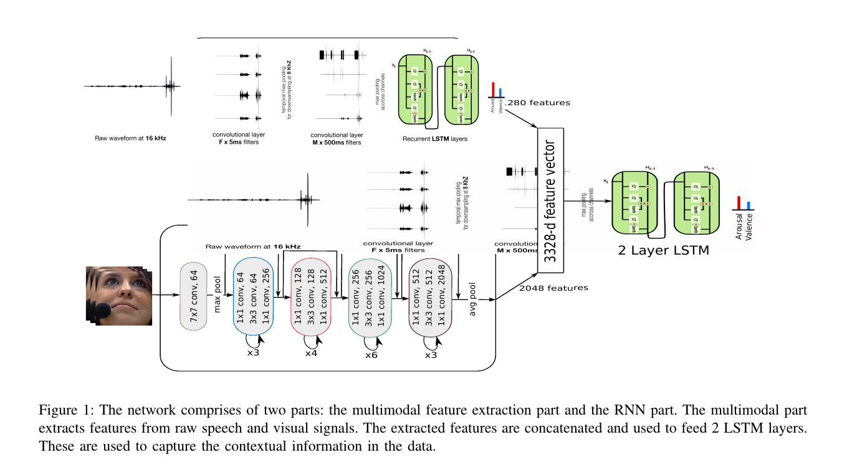

Finally, for all investigated methods, a chain of post-
processing is applied to the predictions obtained on the devel-
opment set: (i) median filtering (with the size of the window
ranging from 0.4 s to 20 s) [7], (ii) centering (by computing
the bias between the gold-standard and the prediction) [47],
(iii) scaling (using the ratio of standard-deviation of the gold-
standard and the prediction as scaling factor) [47] and (iv)
time-shifting (by shifting the prediction forward in time with
values ranging from 0.04 s to 10 s), to compensate for delays
in the ratings [48]. Any of these post processing step is maintained when they find an improvement on the concordante coefficient.
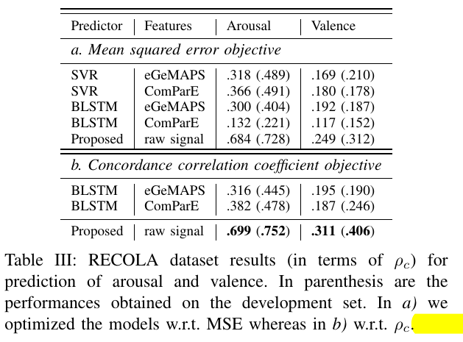
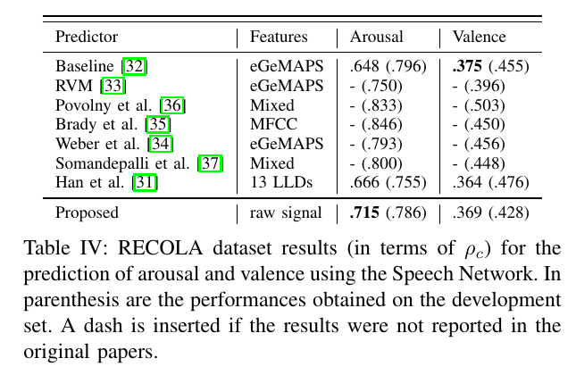
EL DE ARRIBA ES USANDO 46 PARTICIPANTES????(No sé cómo han conseguido los 46 porque se supone que algunos no dieron permiso para usar sus datos) Y EL DE ABAJO, USANDO 27, AVEC 2016

Continuous Estimation of Emotions in Speech by
Dynamic Cooperative Speaker Models

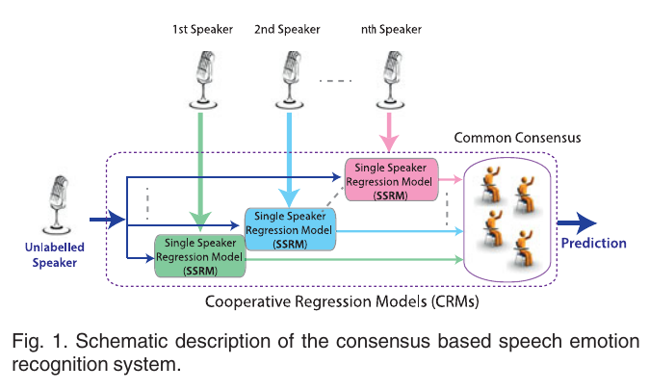

A lo que sale de cada SSRM se le hace el CCC con

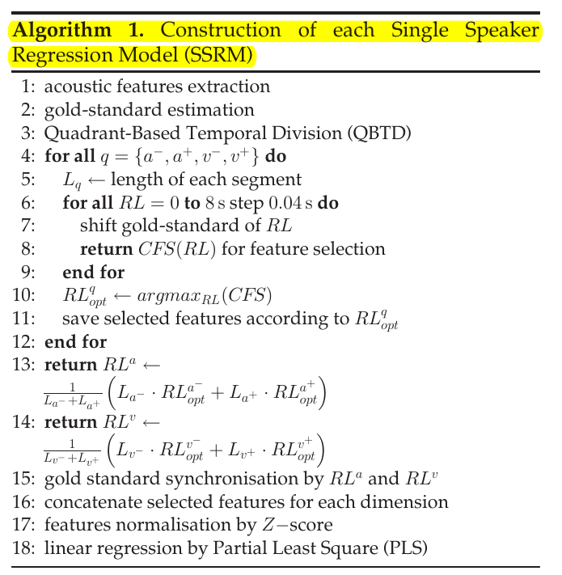

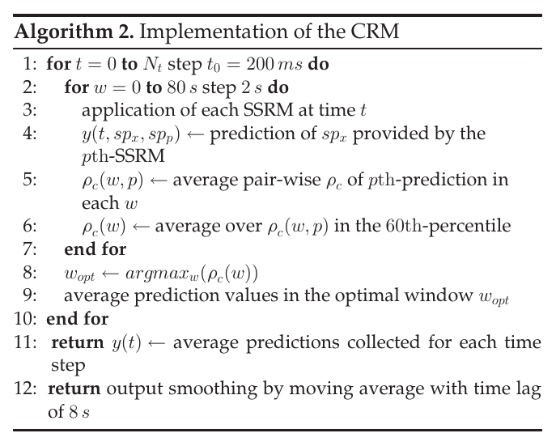

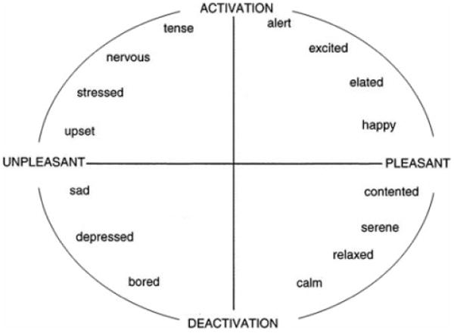
Dividen la valence y activation en +y- para ser capaces de encontrar en qué cuadrante está la emoción.

Speech Emotion Recognition Using Deep
Convolutional Neural Network and Discriminant
Temporal Pyramid Matching

To this end, we firstly extract three channels of
log Mel-spectrograms (static, delta and delta-delta) similar to the
RGB image representation as the DCNN input. Then the AlexNet
DCNN model pre-trained on the large ImageNet dataset is em-
ployed to learn high-level feature representations on each segment
divided from an utterance. The learned segment-level features
are aggregated by a Discriminant Temporal Pyramid Matching
(DTPM) strategy. DTPM combines temporal pyramid matching
and optimal Lp-norm pooling to form a global utterance-level
feature representation, followed by the linear Support Vector
Machines (SVM) for emotion classification. Experimental results
on four public datasets, i.e., EMO-DB, RML, eNTERFACE05
and BAUM-1s, show the promising performance of our DCNN
model and the DTPM strategy. Another interesting finding is that
the DCNN model pre-trained for image applications performs
reasonably good in affective speech feature extraction.

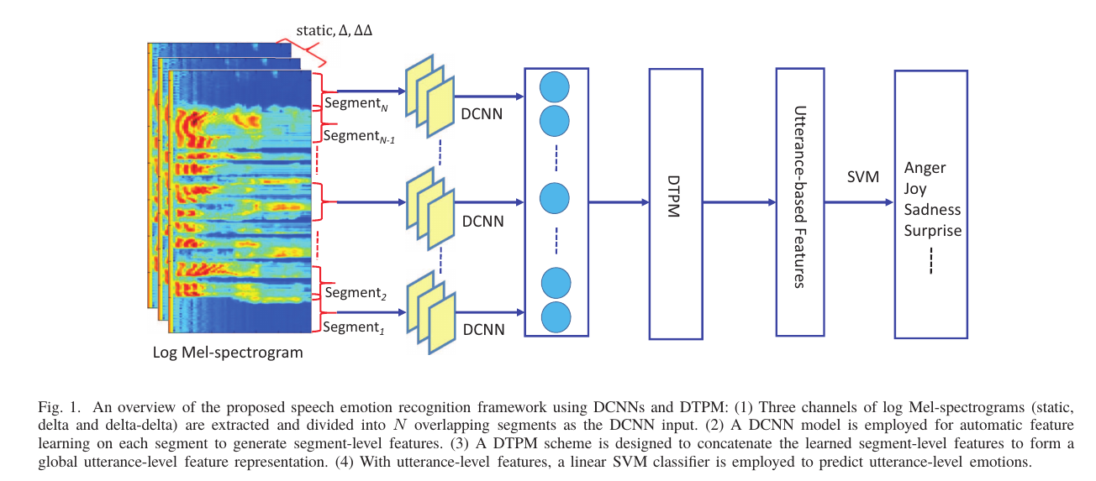

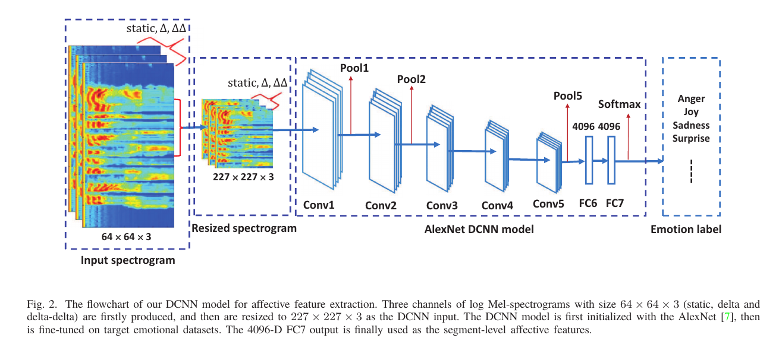
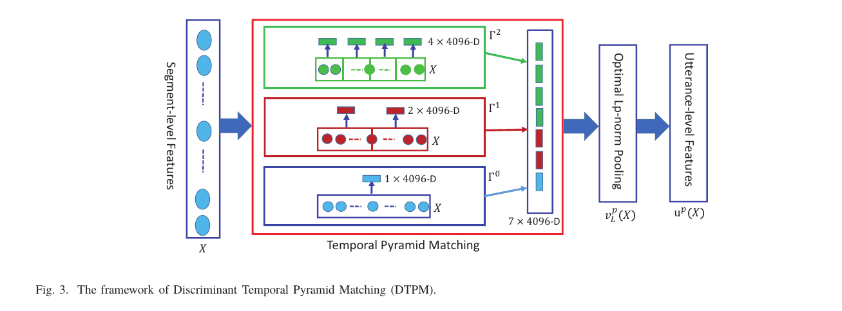

DUDAS O COSAS A MIRAR:
- ¿AUTO ENCODERS O SPARSE-AUTO-ENCODER?

BÚSQUEDAS OTROS MODELOS:

Contributing
There are a plenty of work to be done. All contributions are welcome :).

asr-related work
- Add new layers
  - Batch normalized recurrent neural networks arXiv
  - Batch recurrent normalization arXiv
- Reproduce topologies and results
  - EESEN
  - Deep Speech 2
  - ConvNet-based architectures
- Add language model
  - WFST
  - RNNLN
  - Beam search decoder with LM or CLM
- Encoder-decoder models with attention mechanism
- ASR from raw speech
- Real-time ASR

brsp-related work
- Investigate the brsdv1 model with
  - Multiplicative integration arXiv
  - Layer nomalization arXiv
  - Zoneout arXiv
- Increase the number of datasets (ideally with free datasets)
- Improve the LER
- Train a language model

code-related work
- Test coverage
- Examples
- Better documentation
- Improve the API
- More features extractors, see audio and text
- More datasets parsers
  - LibriSpeech
  - Teldium)
  - WSJ
  - Switchboard
  - TIMIT
  - VCTK
- Implement a nice wrapper for Kaldi in order to enjoy their feature extractors
- Better way of store the entire preprocessed dataset

Known bugs
- High memory and CPU consumption
- Predicting with batch size greater than 1 (Keras' bug)
- warp-ctc does not seem to speed up training
- zoneout implementation

